**Chapter 12: Environmental Chemistry - Water**

**All Lectures Uploaded on YouTube:**

[**https://tinyurl.com/fkm9-chemistry**](https://tinyurl.com/fkm9-chemistry)



**Introduction to Water Quality and Issues** 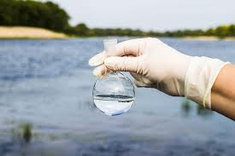

Water comes from various sources (groundwater, lakes, rivers, etc.), and its quality varies. Poor water quality can cause health issues and environmental harm.

* Wastewater disposal: Often dumped into open gutters → flows into rivers/oceans → spreads diseases, harms aquatic life.
* Need for treatment: Both public and private water sources need treatment to ensure safety. Wastewater must be treated before release.

**12.1. Properties of Water**

* Water is the only substance naturally found in three states on Earth: solid (ice), liquid (water), gas (water vapor).
* Pure water: colorless, odorless, tasteless, boils at 100°C, freezes at 0°C at sea level.

**12.1.1. Water as a Solvent**

Water dissolves many substances:

∙ Rainwater absorbs gases from air (O₂, N₂, CO₂, HNO₃ during thunderstorms).

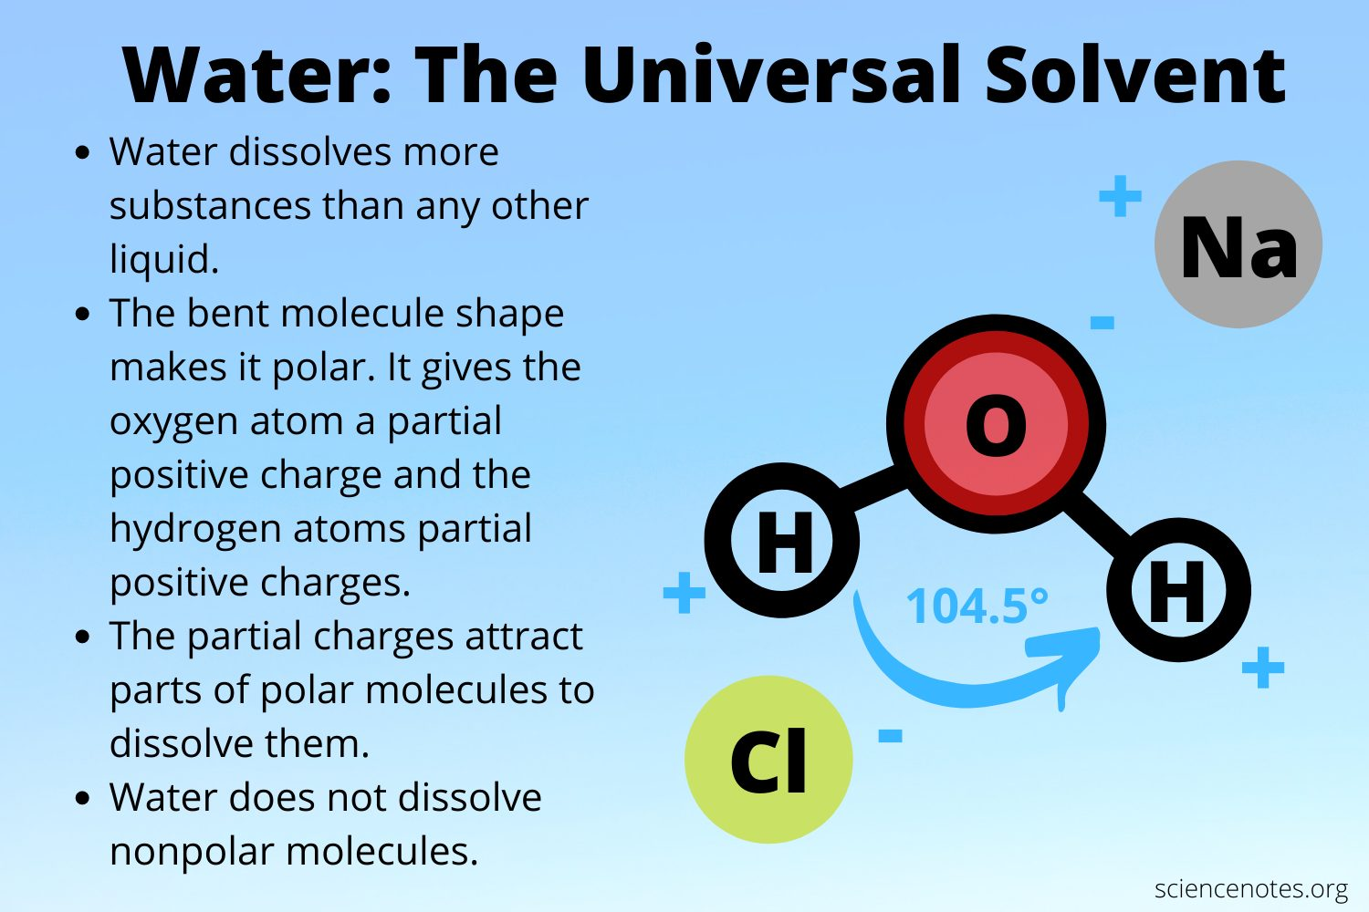

∙ Groundwater dissolves minerals from rocks/soil and organic matter from decaying plants/animals.

**12.1.2. Quality of Water from Natural Resources**

Natural water contains dissolved substances that can be beneficial or harmful.

**12.1.3. Disadvantages of Natural Substances in Water**

| **Substance** | **Effect** |
| --- | --- |
| **Dissolved Oxygen** | Essential for aquatic life, but depletion causes death. |
| **Metal Compounds** | Necessary in trace amounts, but high concentrations toxic. |
| **Plastics** | Pollute water, harm aquatic life and ecosystems. |
| **Wastewater** | Contains pathogens, bacteria, viruses → diseases. |
| **Harmful Microbes** | Cause waterborne diseases (cholera, dysentery, diarrhea). |
| **Nitrates (fertilizers)** | Health risks, especially to infants (blue baby syndrome). |
| **Phosphates** | Cause eutrophication → algal blooms → oxygen depletion in water. |
| **Detergents** | Damage fish mucous membranes and gills, increase phosphate levels. |

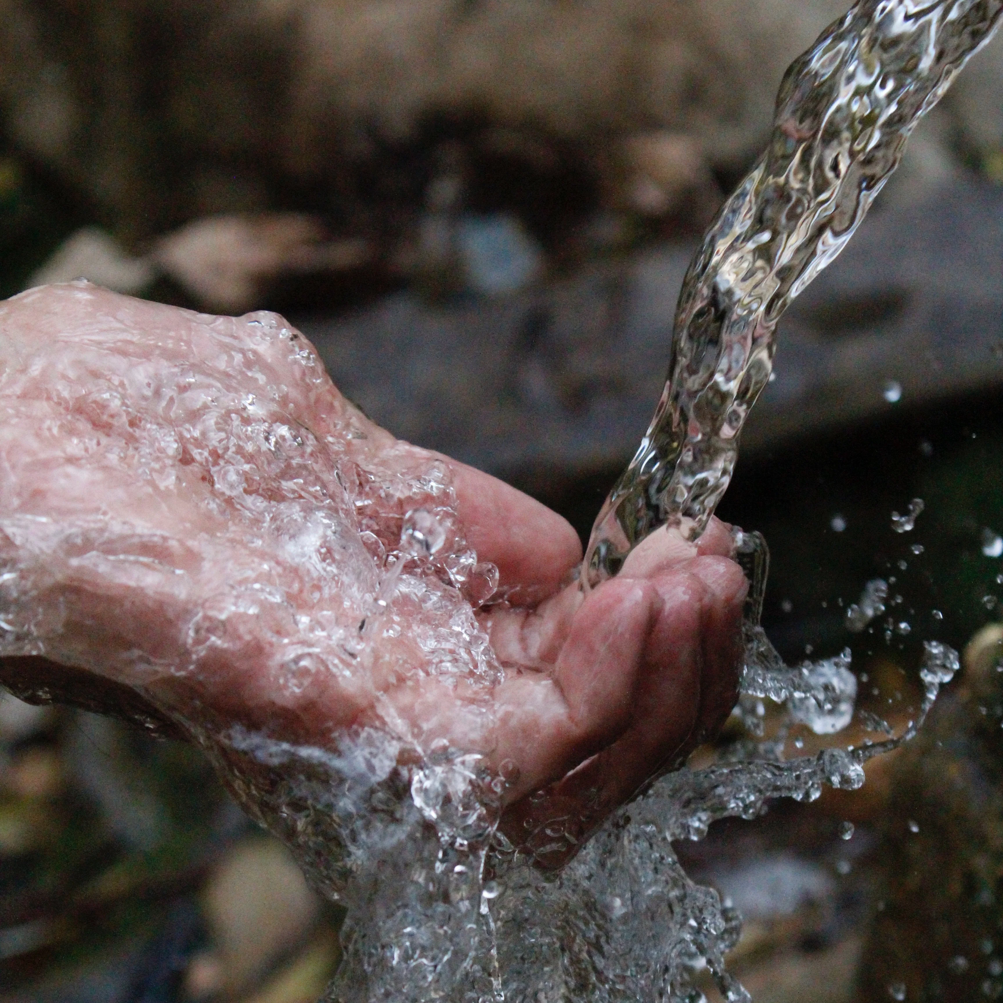

**12.1.4. Benefits of Natural Substances in Water**

Some natural substances are essential for life:

1. Dissolved Oxygen: Supports respiration of aquatic organisms.

2. Essential Minerals:

o Iron: Needed for hemoglobin production.

o Zinc, Copper, Manganese: Activate enzymes for biological processes.

**12.2. Treatment of Domestic Water Supply**

Process to make raw water safe for drinking and domestic use.

**Stages in Municipal Water Purification:**

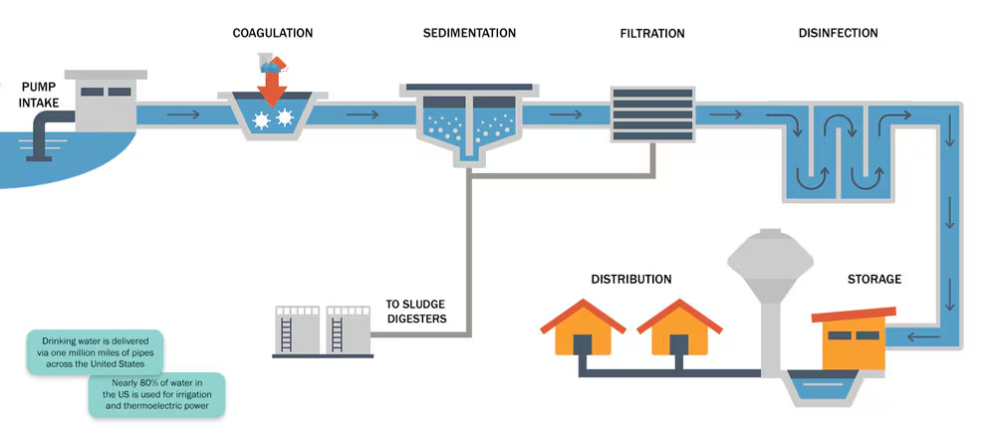

**Flowchart of Water Treatment Process:**

Raw Water

↓

Sedimentation → Suspended particles settle

↓

Coagulation → Alum + Slaked lime → Al(OH)₃ gel traps impurities

↓

Filtration → Removes remaining particles

↓

Disinfection → Kills microbes (e.g., chlorination)

↓

Clean Water → Distributed to homes

**Detailed Steps:**

**1. Sedimentation:**

Water stands in the reservoir → suspended matter settles.

**2. Coagulation:**

Chemicals added (alum + slaked lime) → form aluminum hydroxide gel → traps fine particles.

Chemical Reaction:

3Ca(OH)2(aq)+Al2(SO4)3(aq)→2Al(OH)3(s)+3CaSO4(aq)

**3. Filtration:**

Removes remaining impurities.

**4. Disinfection:**

Chlorine or other disinfectants kill pathogens.

**5. Environmental Impacts of Poor Water Management**

∙ Eutrophication: Excess nutrients (nitrates, phosphates) → algae overgrowth → oxygen depletion → dead zones.

∙ Bioaccumulation: Plastics and toxins enter the food chain → affect humans.

∙ Disease spread: Pathogens in untreated wastewater cause outbreaks.

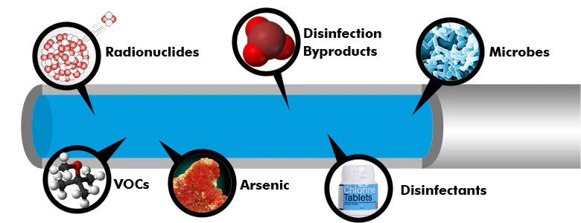

**Water Contaminants & Effects**

| **Contaminant Type** | **Source** | **Impact** |
| --- | --- | --- |
| **Metals (Fe, Zn, Cu)** | Natural rocks, pollution | Essential in trace amounts, toxic in excess |
| **Nitrates** | Fertilizers, runoff | Health risks, eutrophication |
| **Phosphates** | Detergents, fertilizers | Algal blooms, oxygen depletion |
| **Pathogens** | Wastewater | Waterborne diseases |
| **Plastics** | Human waste | Ecosystem damage, enters food chain |
| **Detergents** | Household use | Damages aquatic life, adds phosphates |

**Coagulation to Chlorination**

After sedimentation and coagulation with alum and slaked lime, the process continues:

**Filtration:**

∙ Water passes through sand and gravel layers.

∙ Sometimes activated charcoal is used to remove color, odor, and organic compounds.

**Chlorination:**

∙ Chlorine (Cl₂) is added to kill remaining bacteria.

∙ Chlorine reacts with water to form hypochlorous acid (HClO), a strong disinfectant.

Chemical Reaction:

Cl2(aq)+H2O(l)→HClO(aq)+H+(aq)+Cl−(aq)

**Final Flowchart:**

Raw Water

↓

Sedimentation → Settles suspended solids

↓

Coagulation → Alum + Lime → Al(OH)₃ gel traps particles

↓

Filtration → Sand, gravel, charcoal remove fine impurities

↓

Chlorination → Kills pathogens with Cl₂

↓

Pure Water → Safe for distribution

**Types of Purified Water**

**12.2.1. Distilled Water**

Process: Boiling → condensation of steam → impurities left behind.

Properties:

* pH = 7 (neutral)
* Very low electrical conductivity
* Free from minerals, contaminants, bacteria

Uses in Chemistry:

o Preparing chemical reagents

o Calibrating pH meters and sensors

∙ Health Note: Not ideal for long-term drinking → lacks essential minerals → can cause mineral deficiencies.

**12.2.2. Tap Water**

Source: Municipal supply from rivers, lakes, reservoirs, groundwater.

Treatment: Meets safety standards through purification.

Uses in Lab:

o Cleaning glassware

o General solvent for demonstrations

o Not used for precise experiments due to dissolved minerals.

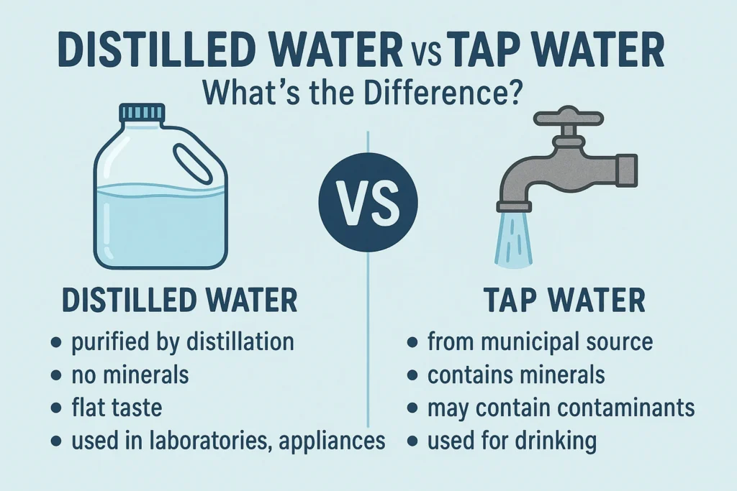

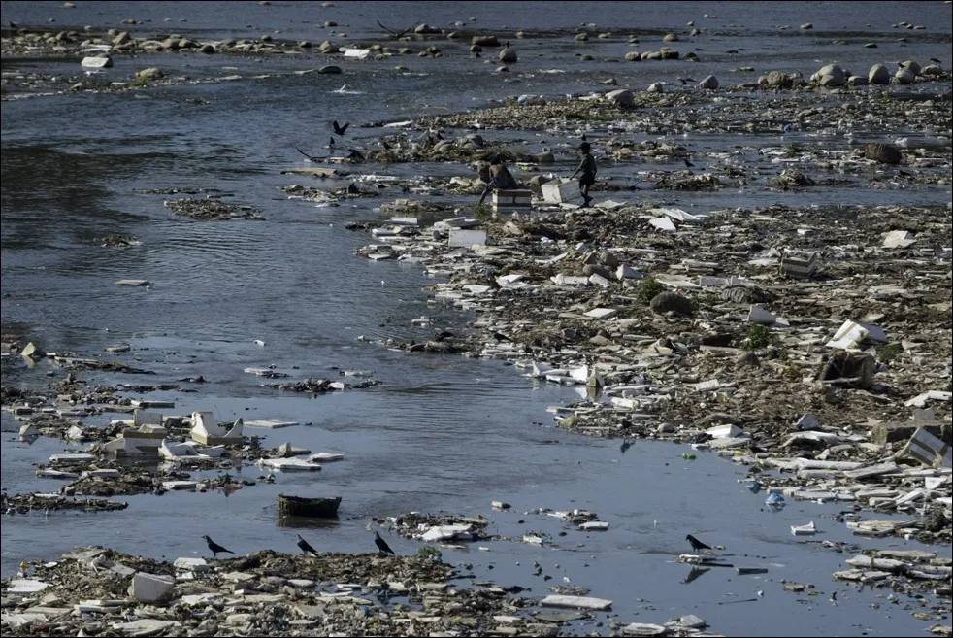

**12.3. Water Pollution**

Causes of Pollution

As water moves through the environment, it dissolves minerals and pollutants from:

**Natural sources:** Minerals from rocks and soil.

**Human activities:**

∙ Household waste

∙ Agricultural runoff (fertilizers, pesticides)

∙ Industrial discharge

∙ Oil spills

∙ Detergents, soaps

∙ Septic tanks

∙ Petroleum and gas production

**Household Waste and Its Impact**

| **Waste Type** | **Examples** | **Impact on Water** |
| --- | --- | --- |
| **Human & Livestock Waste** | Feces, urine | Pathogens → cholera, typhoid, hepatitis |
| **Soaps & Detergents** | Cleaning agents | Eutrophication, toxic to fish, long persistence |
| **Paints & Oils** | Solvents, hydrocarbons | Toxic to aquatic life, hard to remove |
| **Food & Vegetable Waste** | Organic matter | Decomposes → uses up oxygen → kills aquatic life |
| **Garbage** | Plastics, packaging | Physical pollution, enters food chain |

**Specific Harm from Detergents:**

* Stronger cleaning power than soap but persists in water.
* Removes protective mucus from fish → exposes to bacteria/parasites.
* Damages fish gills.
* Contains phosphates → algal blooms → oxygen depletion.

**Benefits of Water Treatment**

| **Benefit** | **Explanation** |
| --- | --- |
| **Prevents Epidemics** | Removes pathogens causing cholera, typhoid, hepatitis, polio |
| **Removes Heavy Metals** | Arsenic (As), Chromium (Cr), Lead (Pb) → cause cancer, neurological issues |
| **Improves Taste & Appearance** | Removes odors, colors, suspended particles |
| **Protects Aquatic Life** | Reduces toxins entering rivers/lakes |
| **Safe for Daily Use** | Makes water potable and suitable for domestic purposes |

**Diseases from Contaminated Water**

* Cholera – Bacterial infection from Vibrio cholerae
* Typhoid – Salmonella typhi
* Hepatitis – Viral infection affecting liver
* Dysentery – Severe diarrhea with blood
* Polio – Poliovirus
* Botulism – Rare but serious illness from toxic materials

**12.4. Waterborne Diseases**

Waterborne diseases are caused by pathogens (bacteria, viruses, parasites) in contaminated water due to poor sanitation and waste disposal.

**Common Waterborne Diseases:**

| **Disease** | **Caused by** | **Transmission** | **Symptoms** |
| --- | --- | --- | --- |
| **Dysentery** | Parasite  (Entamoeba) | Fecal contamination of water/food | Abdominal cramps, diarrhea, mucus/blood in stool |
| **Typhoid** | Bacteria  (Salmonella typhi) | Polluted water,  contaminated food | Continuous high fever (101– 104°F), irregular pulse, weakness |
| **Hepatitis Virus** | (Hepatitis A & E) | Polluted water, poor sanitation | Liver inflammation, jaundice, fatigue, loss of appetite |
| **Jaundice** | Often a symptom of liver issues | Result of hepatitis or bile obstruction | Yellow skin/eyes, weakness, fatigue, loss of appetite |
| **Cholera** | Bacteria (Vibrio cholerae) | Contaminated water | Severe diarrhea, dehydration |

* 2.668 million people die yearly worldwide due to unclean water, poor sanitation, and hygiene. 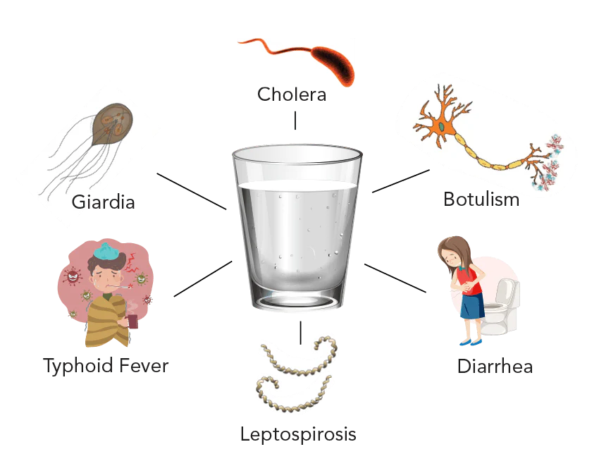
* Chlorination kills bacteria but is less effective against viruses (e.g., hepatitis viruses).
* Swimming pools use aeration and chlorination to control pathogens.

**12.5 Ways To Deal With The Negative Effects Of Water Pollution**

| **Problem** | **Cause** | **Solution** |
| --- | --- | --- |
| **Low Oxygen in Water** | Nutrient runoff → algal blooms | Control nutrient flow; treat sewage/industrial waste |
| **Heavy Metal Accumulation** | Industrial waste | Prevent industrial wastewater from entering waterways |
| **Waterborne Diseases** | Harmful microbes in water | Treat wastewater; ensure sanitation; provide clean drinking water |

**Detailed Actions:**

1. **Control nutrient runoff** to prevent eutrophication.

2. **Treat industrial and domestic wastewater** before discharge.

3. **Promote sanitation and hygiene** to reduce pathogen spread.

4. **Regulate and monitor illegal dumping** and groundwater extraction.

**12.6. Water Scarcity in Pakistan**

**Causes of Water Scarcity:** 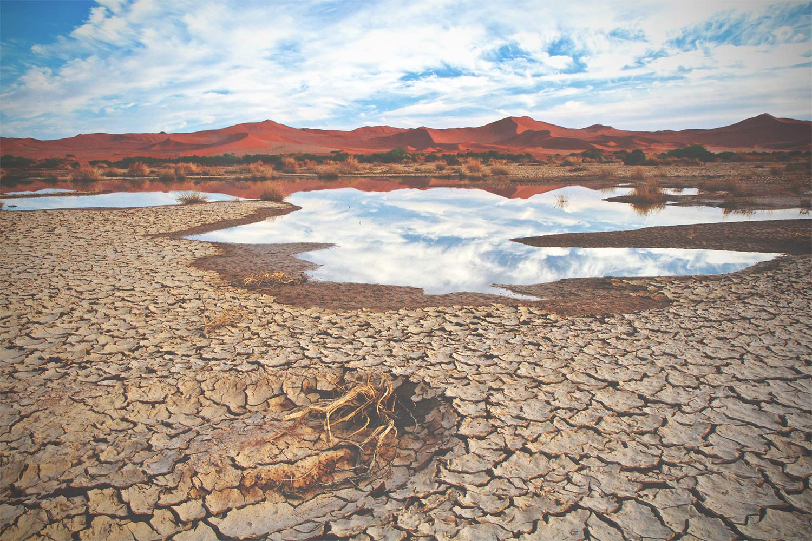

* Population Growth: Increased demand for agriculture, industry, and households.
* Climate Change: Irregular rainfall, reduced water availability.
* Over-extraction of Groundwater: Depletes aquifers.
* Inefficient Irrigation: Flood irrigation causes evaporation and uneven distribution.

**Solutions to Water Scarcity:**

* Effective water management (e.g., drip irrigation)
* Infrastructure development (dams, reservoirs, pipelines)
* Policy reforms for sustainable use
* Public awareness on water conservation
* Regulations to control groundwater extraction and prevent illegal drilling

**12.7. Fertilizers and Their Impact**

**What Are Fertilizers?**

Substances that provide essential nutrients for plant growth: Nitrogen (N), Phosphorus (P), Potassium (K) → NPK fertilizers.

**Common Fertilizers:**

* Urea (Nitrogen)
* Potassium nitrate
* Ammonium salts (e.g., di-ammonium phosphate, superphosphate)

**Benefits:**

* Increase crop yields
* Provide nutrients in water-soluble form for easy plant uptake

**Environmental Risks:**

* Nutrient runoff into water bodies → eutrophication → algal blooms → oxygen depletion → harms aquatic life.

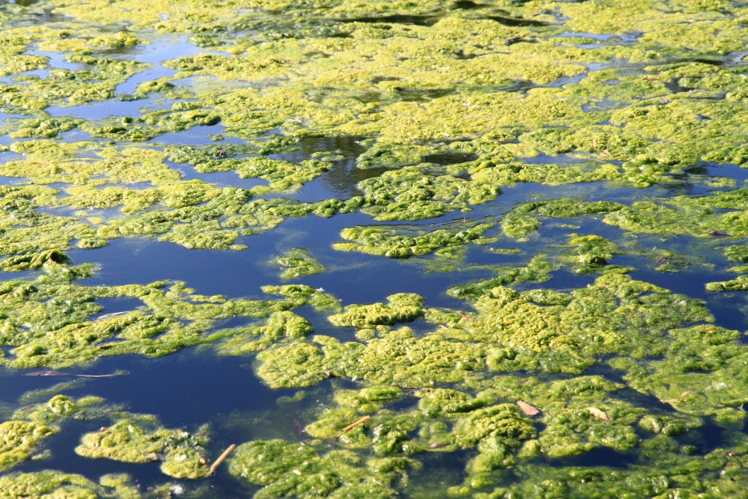

**Nutrient Management:**

* Applying fertilizers at the right time and in the right amount
* Reduces nutrient loss and environmental damage



